# Introduction.

This is the main dashboard of ACC Asia cup matches result since 1980. In this dashboard mainly discussed the total team’s performance of Sri Lanka, India, Pakistan, Bangladesh, Afghanistan, Hong Kong and UAE.

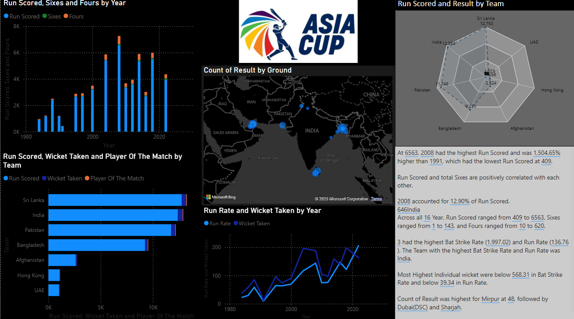To make the main dashboard I have selected 6 types of charts to describe the stories and provide the solutions to the ACC to choose a better place to hold next Asia cup tournament and take a prediction which county may be the champions.

# Target audience.

In below clearly mentioned the who are the target audiences of this visualization.

1.International Cricket council (ICC).

2.Asia Cricket Council. (ACC).

3.Cricket Councils of countries. (India, Sri Lanka, Pakistan etc.)

4.Host nations governments.

5.Sport analysis and media.

# Target are of this storytelling.

* To choose better places to hold the next 3 tournaments.
* Which team scored the most runs in the tournament.
* Which team will win the player of the tournament.
* Which team may qualify for the final and semi-finals.
* Which team has more probability to win next Asia cup.
* To predict the ticket price.
* Next tournament broadcasting channel.

## Choose the better country to nominate as the host nation in the next 3 tournaments.

Even though there are 30 Asian countries are playing cricket only 6 countries can play next Asian cup tournaments.

Only five countries have full memberships of ICC. Three countries have ODI and T20 memberships and 20 countries have only T20 membership.

We can consider only fully ICC members these are **Sri Lanka, India, Pakistan, Bangladesh, Afghanistan.**

Due to the Taliban territory case Afghanistan has been dropped out from the list and **UAE** add this as a replace.

In below attachment can be seen previously tournament held grounds since 1980 to 2021

(wikipedia, 2025)

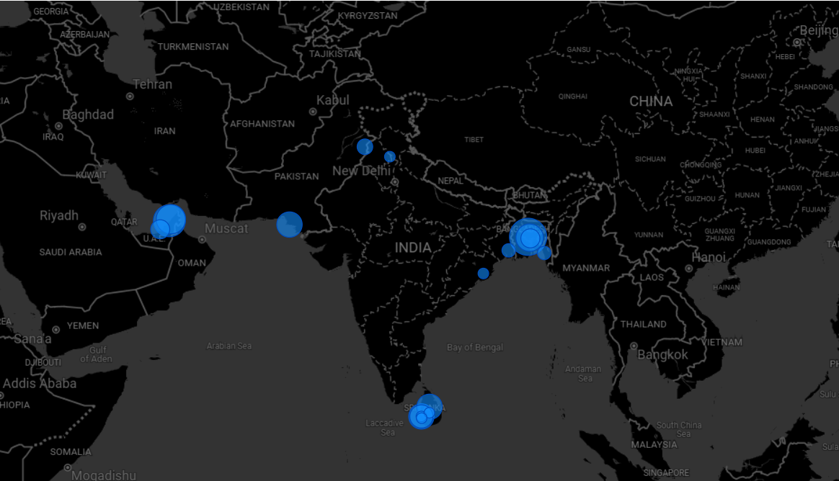

## Tournament dates and duration.

1. 2023 tournament.

* The 2023 Asia cup tournament will start 30th of August to 17th of September in 2023.

1. 2025 tournament.

* 2025 Asia cup tournament will be started 30th of October to 17th November in 2025.

1. 2027 tournament.

* Date not decided yet.

## Ground conditions.

In below natural language query can take an idea about the ground conditions either those are help for batters or not.

* All teams are taken most run rates in Mipure ground in Bangladesh.
* In The Soyza ground in Moratuwa is batters had gotten low batting average the reason for that international matches not playing this ground since two or three decades ago.

### India

In India there are 57 international cricket stadiums located. Mostly they use 10 grounds for tournaments. In the columns below we can see it.

|  |  |  |  |
| --- | --- | --- | --- |
| **Ground name** | **Location** | **Capacity** | **Flood Lights** |
| Eden Gardens | Kolkata | 66000 | Yes |
| Narendra Modi Stadium | Ahmedabad | 132000 | Yes |
| Wankhede Stadium | Mumbai | 32000 | Yes |
| Himachal Pradesh Cricket Association Stadium | Dharamsala | 21200 | Yes |
| Niranjan Shah Stadium | Rajkot | 28000 | Yes |
| M.Chinnaswamy Stadium | Bengaluru | 4000 | Yes |
| Arun Jaitley Stadium | Delhi | 55000 | Yes |
| MA Chidambaram Stadium | Chennai | 38000 | Yes |
| Rajiv Gandhi International Stadium | Hyderabad | 26000 | Yes |
| Vidarbha Cricket Association Stadium | Nagpur | 45000 | No |

(espncricinfo, 2025)

In India average ticket price is USD 40 to USD 350.

**Weather of India in September to November** **month.**

In the September to November month India has very friendly climate because in these couple of months the summer in about to ending and winter is about to beginning.

In those times the probability of match delay or cancellation due to weather conditions is less than other months.

But the Himachal Pradesh Cricket Association Stadium in Dharamsala may not be suitable for use due to the near winter.

In first of September month south Inian average temperatures near 30C and north Indian near to 20C.

Indian weather chart.

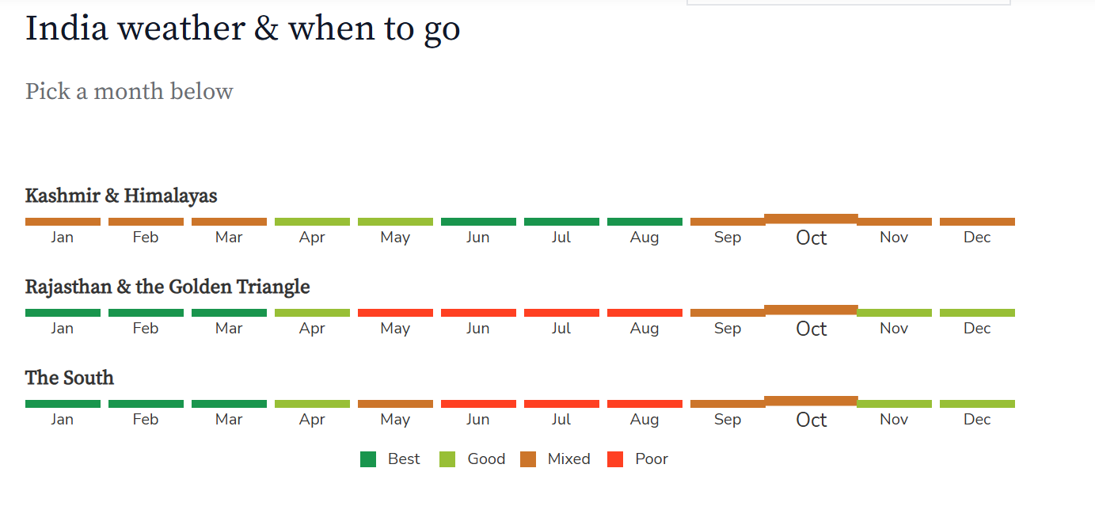

(selectiveasia, 2025)

### Sri Lanka.

Sri Lanka has six international cricket stadiums in the columns below we can see it.

|  |  |  |  |
| --- | --- | --- | --- |
| **Ground name** | **Location** | **Capacity** | **Flood Lights** |
| R.Premadasa Stadium | Colombo | 35000 | Yes |
| Pallekele International Cricket Stadium | Kandy | 35000 | Yes |
| Galle International Stadium | Galle | 5000 | No |
| Rangiri Dambulla International Stadium | Damubulla | 16800 | Yes |
| Mahinda Rajapaksa International Cricket Stadium | Hambanthota | 35000 | Yes |
| Sinhalese Sports Club | Colombo | 1000 | No |

(espncricinfo, 2025)

In Sri Lanka average ticket price between USD 5 to USD 33

**Weather of Sri Lanka in September to November month.**

Althoughin September month Sri Lanka has very friendly climate for playing cricket from middle of October Southwest monsoon will stat.

In September month average temperature 30 C , October month average temperature 24 C but I can be drop down to 20 C and November month average temperature 23C – 19 C.

In the October months and November months The Pallekale ground not suitable for use and the Sooriyawewa ground is better to use.

Sri Lanka weather chart.

(selectiveasia, 2025)

### Pakistan.

Pakistan has four main cricket grounds in the columns below we can see it.

|  |  |  |  |
| --- | --- | --- | --- |
| **Ground name** | **Location** | **Capacity** | **Flood Lights** |
| Gaddafi Stadium | Lahore | 27000 | Yes |
| National Stadium Karachi | Karachi | 34238 | Yes |
| Rawalpindi Cricket Stadium | Rawalpindi | 15000 | Yes |
| Multan Cricket Stadium | Multan | 35000 | Yes |

In Pakistan average ticket price between USD 2 to USD 70

**Weather of Pakistan in September to November month.**

Pakistan has very nice climate to hold this tournament in September to November.

Average temperatures in Pakistan in September to November among 27C to 35C.

In Pakistan whole year there is limited raining to whole county.

Pakistan weather chart.

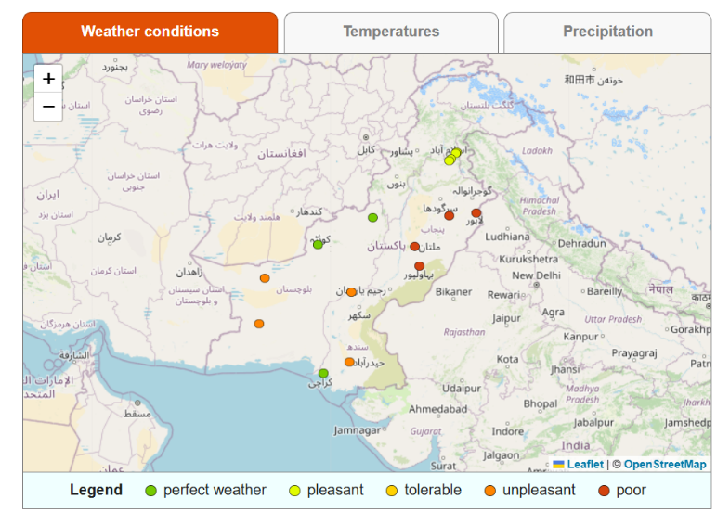

(weather-and-climate, 2025)

Bangladesh.

Bangladesh has three main cricket grounds in the columns below we can see it.

|  |  |  |  |
| --- | --- | --- | --- |
| **Ground name** | **Location** | **Capacity** | **Flood Lights** |
| Zahur Ahmed Chowdhury | Chattogram | 18148 | Yes |
| Shere Bangla National Stadium | Mirpur, Dhaka | 25000 | Yes |
| Sylhet International Cricket Stadium | Sylhet | 18000 | No |

In Bangladesh average ticket price between USD 10 to USD 30

**Weather of Bangladesh in September to November month.**

The Southwest monsoon will start into Bangladesh in May month.

All of Bangladesh ground are very suitable for held the tournament due to low of raining probability.

Average temperatures of these months in Bangladesh is among 33C to 30C.

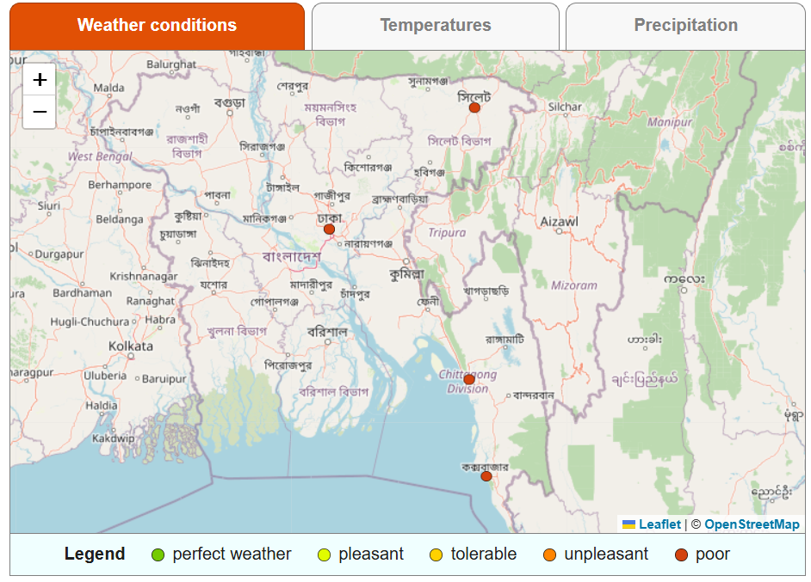

(weather-and-climate, 2025)

### UAE.

UAE five three main cricket grounds in the columns below we can see it.

|  |  |  |  |
| --- | --- | --- | --- |
| **Ground name** | **Location** | **Capacity** | **Flood Lights** |
| Dubai International Cricket Stadium | Dubai | 25000 | Yes |
| Sharjah Cricket Stadium | Sharjah | 16000 | Yes |
| Zayed Cricket Stadium | Abu Dhabi | 20000 | Yes |
| tolerance oval | Abu Dhabi | 12000 | Yes |

(espncricinfo, 2025)

In UAE the average ticket price is between USD 55 to USD 135

**Weather of UAE in September to November month.**

The whole year in UAE there is a low probability of rain.

AS I know in history there is not any match had delay or cancelled in UAE due to a weather condition.

But in these months in UAE the temperature is going very high between 39C to 35C.

In that temperature some players and another county audience may not willing to play and visit the ground.

## Suggestion.

* Next ODI world cup will be held in India, and it will be started on 05 of Oct 2023.The next Asia cup tournament will be an ODI tournament. This tournament will be held between 30 August to 17 September. So India needs more time to prepare for ODI world cup due to the above reasons India should be dropped from the selected list only for 2023.
* Bangladesh has only 3 international stadiums one of the has no **Flood lights.** Due to the lack of stadium facilities Bangladesh can be ignore from the selected list.
* Selecting the Pakistan there are several matters to consider. India not willing travel to Pakistan and some other team players not willing due to the security matters.
* Considering the UAE the last year the tournament had been held on UAE.
* According to my opinion **Sri Lanka should be nominating as the host nation of 2023 Asia cup.** There are 5 better stadiums in Sri Lanka with 20000+ capacity. very low distance between the stadiums, very friendly climate in September month And mainly Sri Lanka is facing to economic crisis holding this tournament is there may be much help for them.
* In my suggestion in **2025 the tournament should be held on India** because, previously India was nominated as the host nation in 1990 and India better facilities comparing other nations.
* **Bangladesh should be nominated as Host nation for 2027**.becouse last time the Bangladesh nominated in 2016, and they have three stadiums with more than 15000 capacities.

# Winning probability analysis.

Referring the below attached Radar chart Sri Lanka, India, Pakistan and Bangladesh are best countries in Asian cup tournament.

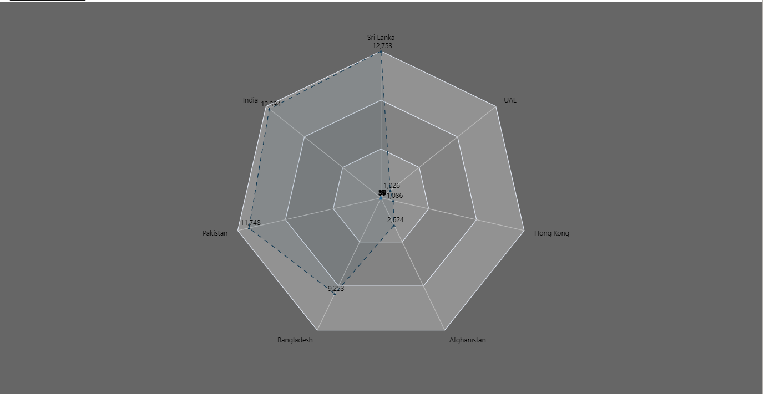Hong Kong is dropped from the list because they have not selected for the 2023 tournament.

The three countries mentioned have been playing in the Asia cup since the day it started.

### India.

* Since the Asia cup tournament started Indian team performance is in high stranded, and India is eight times Asia cup winners.
* India team has many players with more than 10-years’ experience and most of them are in the form.

Ex – Virat kohli, Rohith Sharma, KL Rahul, Jasprit Bumrah, Kuldeep Yadav

* As I mention earlier if Sri Lanka were the host nation India has better opportunities to win the Asia cup. Because they have better experience playing in Sri Lanka.
* Sri Lankan pitches help for spinners and batters. So, India has powerful batting lineup and spinner attack.
* Since the tournament started India won 59 player of match awards, scored 12394 and taken 453 wickets.

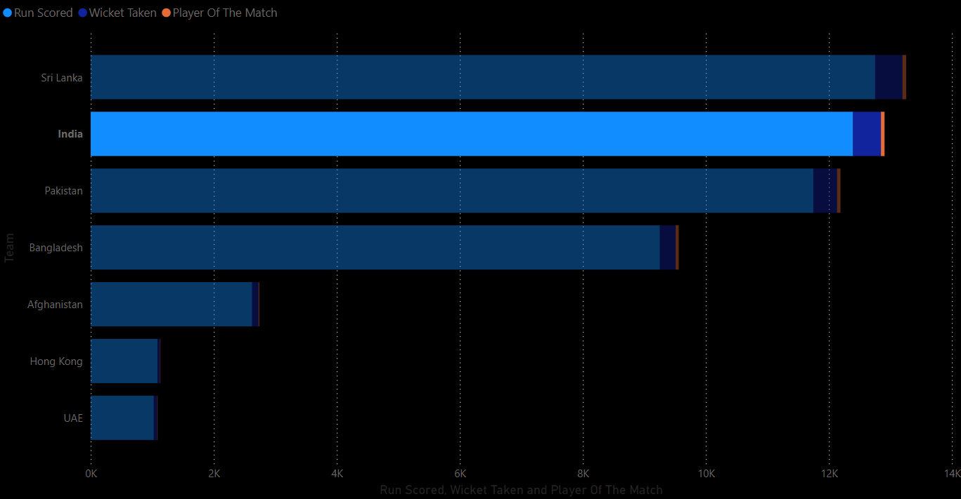

**Indian batting and balling performance for each year.**

* In the below attachment bar chart shows how the Indian batting lineup worked since 1980.

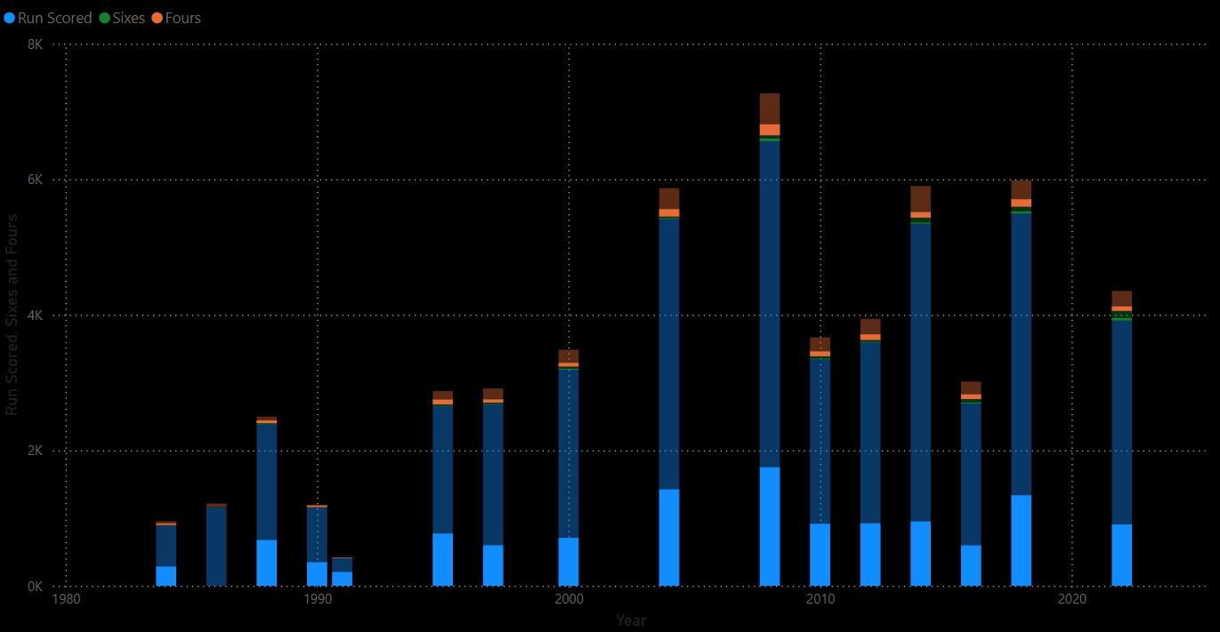

Referring attachment India score their highest score 1750 runs in 2008.

Since the Asia cup started Indian team scored more than 12000 runs.

In the below line chart shows how run rates and wickets taken.

India have taken 453 wickets in all Asia cup tournaments.

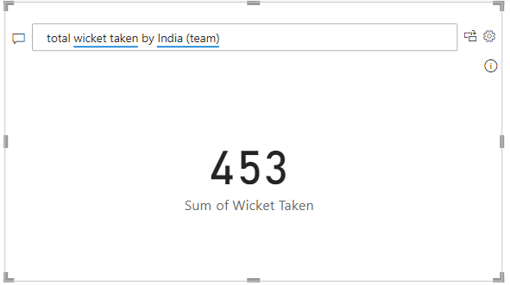

**In the below column shows Indian total performance.**

|  |  |  |  |  |  |  |
| --- | --- | --- | --- | --- | --- | --- |
| Year | Runs. | Run rate | Wicket taken | Sixes | Fours. | Result |
| 1984 | 285 | 8.55 | 20 | 7 | 22 | Win |
| 1986 |  |  |  |  |  |  |
| 1988 | 677 | 17.96 | 34 | 8 | 39 | Win |
| 1990 | 349 | 8.52 | 16 | 3 | 21 | Win |
| 1991 | 205 | 4.86 | 9 | 1 | 7 | Win |
| 1995 | 772 | 21.62 | 35 | 6 | 71 | Win |
| 1997 | 598 | 18.12 | 14 | 6 | 46 | Run up |
| 2000 | 708 | 16.08 | 21 | 15 | 54 | Semi final |
| 2004 | 1423 | 29.52 | 51 | 13 | 110 | Run up |
| 2008 | 1750 | 38.30 | 40 | 38 | 162 | Run up |
| 2010 | 916 | 21.17 | 33 | 9 | 72 | Win |
| 2012 | 923 | 18.75 | 21 | 9 | 83 | Semi final |
| 2014 | 949 | 20.83 | 34 | 15 | 82 | Semi final |
| 2016 | 597 | 37.99 | 40 | 14 | 69 | Win |
| 2018 | 1338 | 31.66 | 53 | 31 | 109 | Win |
| 2022 | 906 | 45.42 | 32 | 38 | 66 | Semi final |

This is the total performance of India in Asia cup. Referring the column India in a high stand since 1980 to now 15 tournaments were held, and India has won 7 of them. India is the most successful team in Asia cup competitions.

In the below Narrative shows **Indian** team history in details wise.

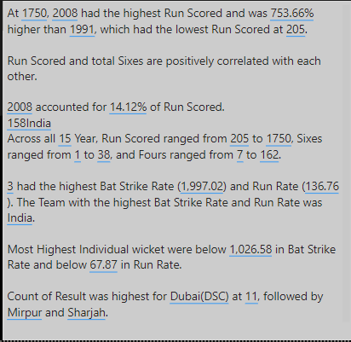

### Sri Lanka.

* Sri Lanka is six times Asia cup winners and since the tournament started most run (Sanath jayasooriya) and most wicket (Lasith Malinga) awarded belongs to Sri Lanka
* Sri Lanka has better young team some of them has more than 8 years of experiences in international cricket.

Ex – Angalo Mathews, Kusal Perera, Kusal Mendis, Dasun Shanaka.

* As the host nation Sri Lanka has many opportunities familiar with ground conditions and on hand experience more than other countries.
* Sri Lanka belongs the ground preparing authority as the host nations.
* 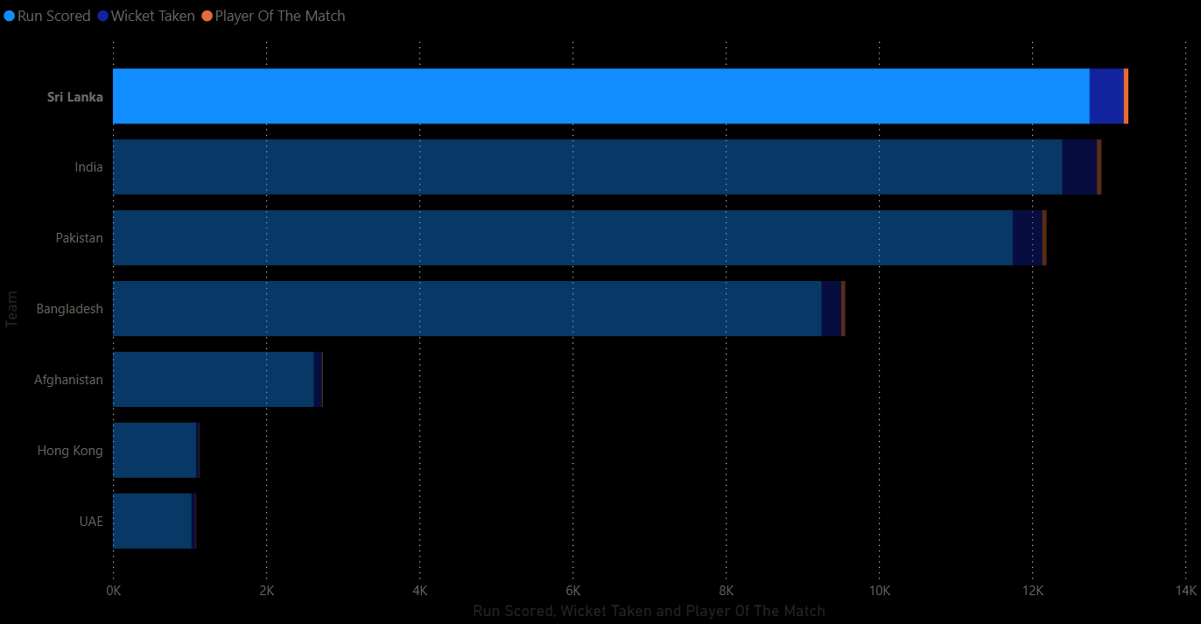In Asia cup history Sri Lanka won player of the match award 60 times, scored 12753 runs and taken 444 wickets.

**Sri Lanka batting and balling performance for each year.**

* **A graph of blue and brown bars

  Description automatically generated**In below bar chart shows how the Sri Lanka batting lineup perform in Asia cup.

Sri Lanka scored 1984 in 2008. It’s the highest team score in Asia cup history.

Sri Lanka scored more than 13000 runs in Asia cup since it started.

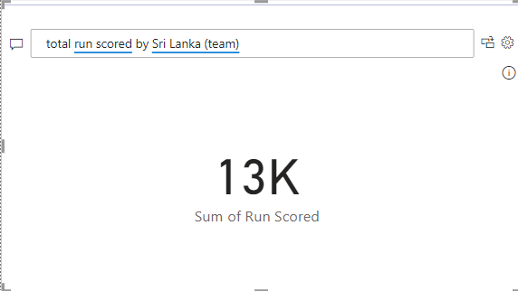

In this line chart shows how average run rate and wicket were taken.

Sri Lanka has taken 444 wickets since it started.

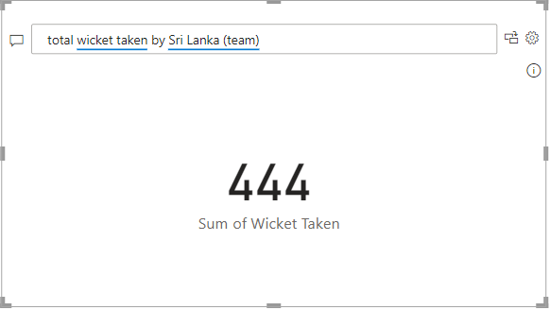

**In the below column shows total performance since 1984.**

|  |  |  |  |  |  |  |
| --- | --- | --- | --- | --- | --- | --- |
| Year | Runs. | Average Run rate | Wicket taken | Sixes | Fours. | Result |
| 1984 | 286 | 6.70 | 9 | 1 | 18 | Runner-up |
| 1986 | 443 | 12.21 | 27 | 1 | 25 | Winner |
| 1988 | 762 | 18.99 | 29 | 3 | 30 | Runner-up |
| 1990 | 463 | 9.86 | 19 | 1 | 2 | Runner-up |
| 1991 | 204 | 4.53 | 3 |  | 3 | Runner-up |
| 1995 | 845 | 19.16 | 23 | 8 | 58 | Runner-up |
| 1997 | 1006 | 22.90 | 30 | 11 | 82 | Winner |
| 2000 | 884 | 20.48 | 23 | 11 | 71 | Runner-up |
| 2004 | 1330 | 29.86 | 52 | 7 | 102 | Winner |
| 2008 | 1862 | 37.25 | 50 | 25 | 171 | Winner |
| 2010 | 952 | 20.88 | 36 | 9 | 86 | Runner-up |
| 2012 | 674 | 14.38 | 12 | 7 | 53 | Semi-final |
| 2014 | 1283 | 26.22 | 46 | 11 | 124 | Winner |
| 2016 | 541 | 27.05 | 25 | 9 | 52 | Semi-final |
| 2018 | 282 | 7.32 | 20 | 5 | 18 | Out from qualifier rounder |
| 2022 | 936 | 48.73 | 43 | 33 | 78 | Winner |

Sri Lanka is 6 times winners and 7 times runner-up winners. In 2018 Sri Lanka out from the first round.

Analyzing above data Sri Lanaka is a successful team same as India.

In the below Narrative shows **Sri Lankan** team history in details wise.

### Pakistan.

* Pakistan won the Asia cup in 2 times (2000 and 2012) in sixteen tournaments.
* Now a days Pakistan has powerful team and most of the in good form. Most of them and very young with more than 5 years’ international experience.

Ex – Mohamad Rizwan, Babar Asam, Shaheen affiridy.

* Pakistan has best spinners since long time If Sri Lanka were the Host nation Pakistan Spinners can do their job better.
* A screenshot of a computer

  Description automatically generatedIn the Asia cup history Pakistan has won the man of the match award in 55 times, taken wicket 386 and scored 11748 runs.

(wikipedia, 2025)

**Pakistan batting and balling performance.**

Below bar chart shows how Pakistan batting line perform in Asia cup.

Pakistan batting scores since the tournament started.

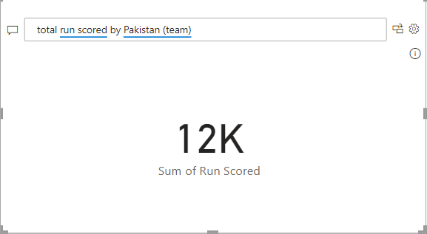

Average run rate and wicket taken history since 1984 shows by line chart.

Pakistan taken wickets since 1984.

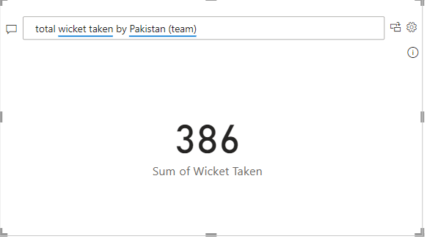

**In the below column shows total performance of Pakistan since 1984.**

|  |  |  |  |  |  |  |
| --- | --- | --- | --- | --- | --- | --- |
| Year | Runs. | Average Run rate | Wicket taken | Sixes | Fours. | Result |
| 1984 | 321 | 7.43 | 9 | 3 | 14 | Semi final |
| 1986 | 486 | 11.65 | 25 | 7 | 29 | Runner-up |
| 1988 | 620 | 14.06 | 17 | 4 | 21 | Semi final |
| 1995 | 596 | 14.00 | 23 | 10 | 41 | Semi final |
| 1997 | 543 | 10.86 | 20 | 6 | 39 | Semi final |
| 2000 | 1085 | 21.83 | 40 | 18 | 92 | Winner |
| 2004 | 1189 | 25.13 | 41 | 11 | 101 | Semi final |
| 2008 | 1250 | 29.18 | 38 | 10 | 129 | Semi final |
| 2010 | 878 | 17.89 | 21 | 21 | 73 | Semi final |
| 2012 | 1016 | 21.28 | 32 | 10 | 88 | Winner |
| 2014 | 1370 | 27.58 | 32 | 34 | 114 | Runner-up |
| 2016 | 494 | 26.01 | 20 | 13 | 50 | Semi final |
| 2018 | 979 | 22.81 | 26 | 18 | 53 | Semi final |
| 2022 | 921 | 46.66 | 39 | 32 | 61 | Winner |

Pakistan has won 2 times winners and 2-times runner-up team. Comparing Pakistan team statics their successful rate is 12.5%.

In the below Narrative shows **Pakistan** team history in details wise.

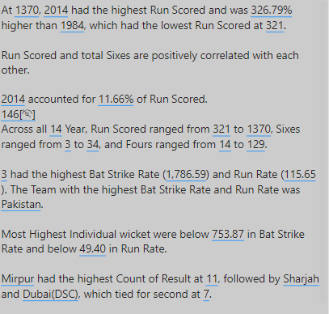

### Bangladesh.

* Bangladesh has been playing the Asia cup tournament since 1986- and 3-times runner-up.
* Bangladesh has some probability to be the winner of next Asia cup. They have talented, experienced and young players.

Ex – Shakib Al Hasson, Saumya Sakara, mushfiqur Rahim

* If Sri Lanka being the host nation Bangladesh may perform well. Because they play well in the 2018 Nidahas trophy tournament.
* Bangladesh has many all-rounders and nice fast balling attack. So, in my opinion Bangladesh may be selected for at least semifinal round.
* **A blue bar graph with red and blue lines

  Description automatically generated**Bangladesh has scored 9253 runs, taken 257 wickets and won 50 times man of the match awards.

**Bangladesh batting and balling performance.**

In below bar chart shows how the Bangladesh batters were performed since 1986.

Bangladesh batting scores since they have been playing.

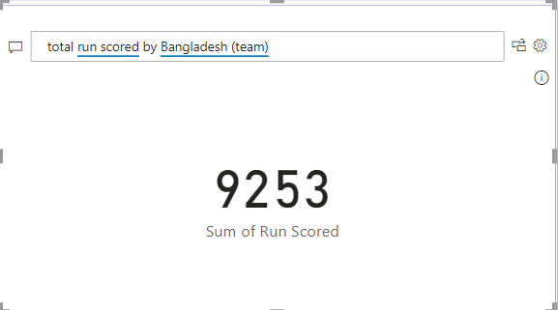

Year by year the wicket taking and average run rate are shown in below line charts.

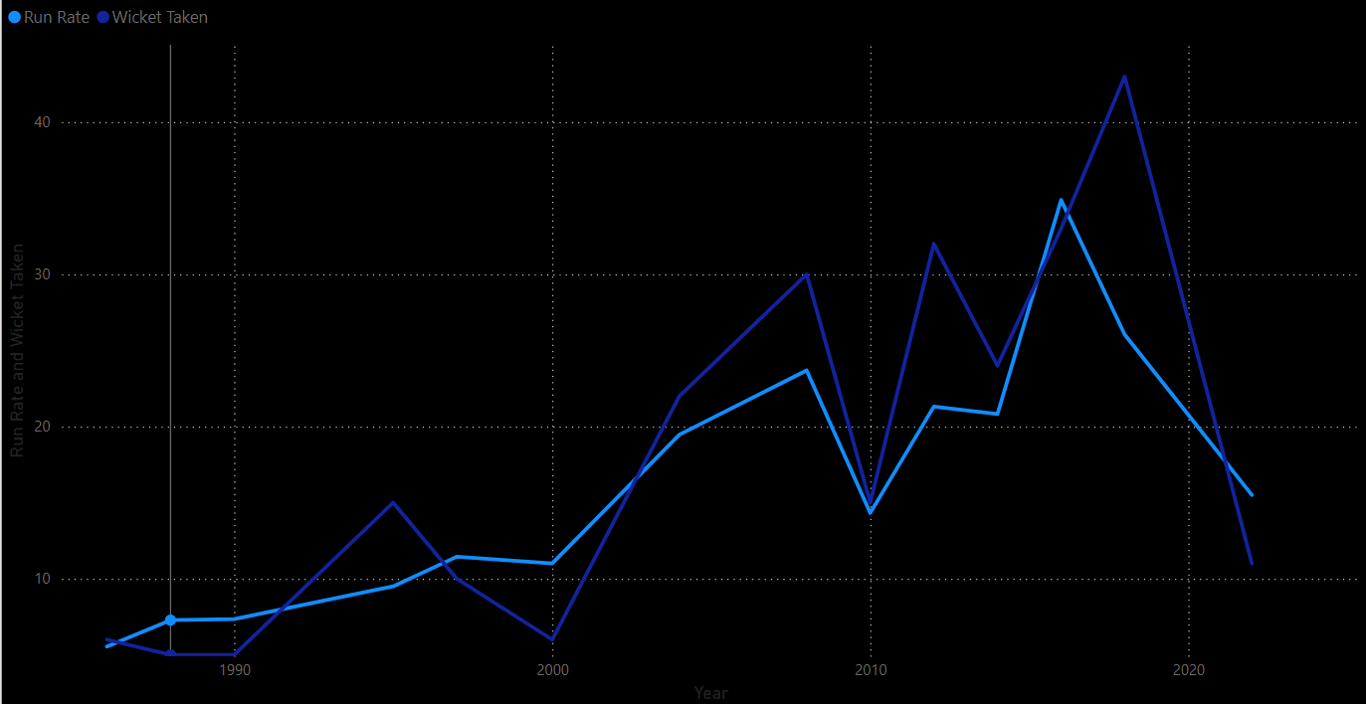

Bangladesh has taken 257 wickets in Asian cup history.

**In the below column shows total performance of since 1984.**

|  |  |  |  |  |  |  |
| --- | --- | --- | --- | --- | --- | --- |
| Year | Runs. | Average Run rate | Wicket taken | Sixes | Fours. | Result |
| 1986 | 225 | 5.55 | 6 | 0 | 0 | Out from 1st round |
| 1988 | 328 | 7.28 | 5 | 0 | 5 | Out from 1st round |
| 1990 | 348 | 7.35 | 5 | 0 | 11 | Out from 1st round |
| 1995 | 440 | 9.50 | 15 | 1 | 27 | Out from 1st round |
| 1997 | 533 | 11.45 | 10 | 2 | 40 | Semi final |
| 2000 | 511 | 11.01 | 6 | 5 | 32 | Out from 1st round |
| 2004 | 935 | 19.47 | 22 | 4 | 61 | Semi final |
| 2008 | 1098 | 23.69 | 30 | 12 | 90 | Out from 1st round |
| 2010 | 599 | 14.32 | 15 | 4 | 50 | Semi final |
| 2012 | 980 | 21.31 | 32 | 10 | 87 | Runner-up |
| 2014 | 1031 | 20.82 | 24 | 19 | 81 | Out from 1st round |
| 2016 | 652 | 34.88 | 33 | 17 | 53 | Runner-up |
| 2018 | 1263 | 26.04 | 43 | 18 | 84 | Runner-up |
| 2022 | 310 | 15.50 | 11 | 7 | 25 | Out from 1st round |

Bangladesh has never succussed in Asia up tournament but 3 times they selected to runner-up.

As per the above data Bangladesh is not too much powerful team in Asia cup tournament.

In the below Narrative shows **Bangladesh** team history in details wise.

### Afghanistan.

* Afghanistan still played 3 Asia cup series 2014, 2018, 2022 years.
* Afghanistan has some chance to select for super 4 round. Because they have well spinners attack with the good experiences.

Ex – Rashid Khan, Mujeeb Ur Rahman, Fazalhaq Farooqi

* If the tournament held in Sri Lanka Afghanistan will play well with their spinner attacks. Sri Lankan pitches are mostly help for spinners.
* A screenshot of a computer

  Description automatically generatedAfghanistan has won 14 men of the match awards, scored 2624 runs and taken 104 wickets.

**Afghanistan performance in Asia cup.**

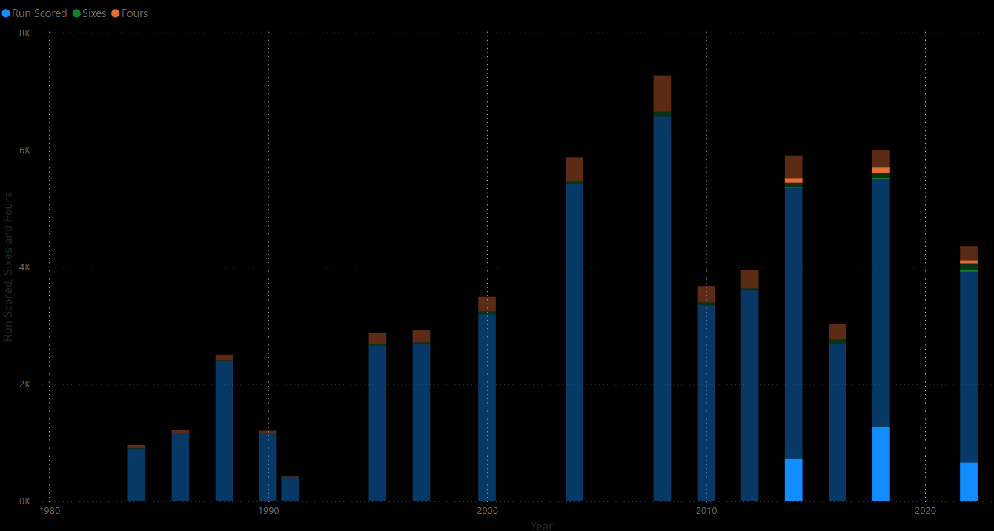In the below bar chart mainly shows the batting performance of Afghanistan.

Afghanistan taken 2624 runs since they joined.

In the Line chart below shows the balling performance of Afghanistan.

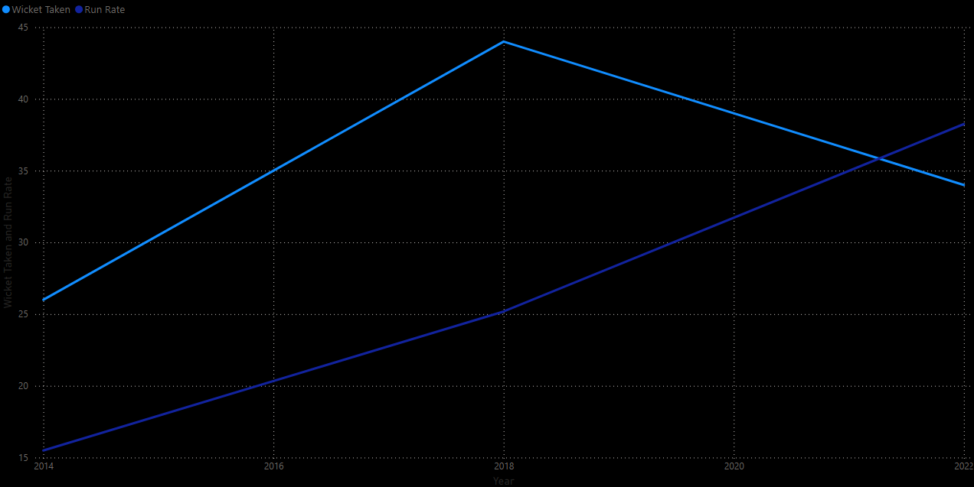

Taken wickets of Afghanistan team.

**In the below column shows total performance of since 1984.**

|  |  |  |  |  |  |  |
| --- | --- | --- | --- | --- | --- | --- |
| Year | Runs. | Average Run rate | Wicket taken | Sixes | Fours. | Result |
| 2014 | 713 | 15.49 | 26 | 9 | 66 | 4th |
| 2018 | 1259 | 25.18 | 44 | 23 | 96 | 4th |
| 2022 | 652 | 38.25 | 34 | 28 | 48 | 4th |

In above details mainly shows how Afghanistan performed in Asia cup tournaments. They have never selected at least one final match.

In the below Narrative shows **Afghanistan** team history in details wise.

### UAE

* UAE has played the Asia cup only 3 times in 2004, 2008 and 2016.
* According to UAE, it may not challenge other teams.
* If Sri Lanka were host national UAE may difficult to play. Because they don’t have much experience playing Sri Lanka.
* 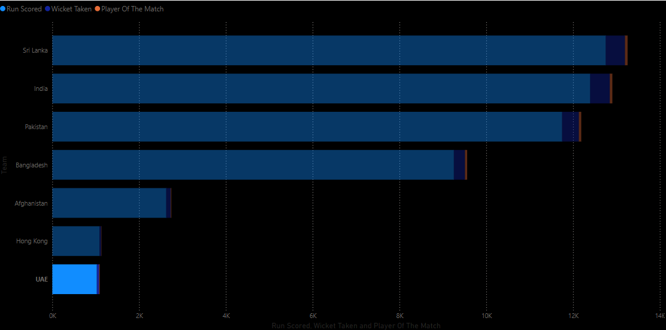UAE has scored 1026 runs, taken 53 wickets and won man of the match awards in 8 times.

**UAE performance in Asia cup.**

In the bar chart below mainly shows the batting performance of UAE

UAE has played only 3 tournaments, and they scored 1026 runs.

In the Line chart below shows the balling performance of UAE.

UAE has taken53 wickets in Asia cup.

|  |  |  |  |  |  |  |
| --- | --- | --- | --- | --- | --- | --- |
| Year | Runs. | Average Run rate | Wicket taken | Sixes | Fours. | Result |
| 2004 | 267 | 6.68 | 16 | 0 | 22 | Out from 1st round |
| 2008 | 352 | 8.51 | 17 | 1 | 38 | Out from 1st round |
| 2016 | 407 | 20.89 | 20 | 13 | 33 | Out from 1st round |

**In the column below shows the total performance of years they played.**

UAE had not performed well during the times they played. In the next tournament they may be very difficult due to lack of experienced players.

In the below Narrative shows **UAE** team history in detail wise.

# Which team scored the most runs in the tournament.

* Referring the above stories either India, Pakistan or Sri Lanka will score the most runs in the tournament.
* According to my opinion, Indian team may be the leading run taking team in next Asia cup tournament.
* India has better batting line up they have good experiences playing in all Asia countries.
* Many of Indian players have experiences playing international cricket and league cricket.
* So, in my opinion **India may be the leading runs taking team in 2023 Asia cup**.
* As the player **Shubman Grill , Kusal Mendis or Pathum Nissanka**. One of them may be the highest individual run taker.

# Which team will win the player of the tournament award.

* Many chance to take the player of the tournament by either Indian, Pakistan or Sri Lanka team.
* Sri Lanka won the man of the match award in 60 times, India in 59 times and Pakistan in 55 times.
* After analyzing previous data either Sri Lanka or India may win.
* Analyzing Sri Lankan now a day plays recodes Indian plays have many chances to win the Man of the tournament award.
* According to my opinion Indian team player mostly win the award. He may be [**Kuldeep Yadav**](https://www.espncricinfo.com/cricketers/kuldeep-yadav-559235)or **Rohith Sharma.**

# Which team may qualify for the final and semi-finals.

* Analyzing the previous data most probably **Sri Lanka, India, Pakistan** and **Bangladesh** will play the Semi-final game.
* India, Sri Lanka, Pakistan definitely will select to semi-final. There may be competition with the Bangladesh and Afghanistan.
* Comparing the Bangladesh and Afghanistan teams talents and experiences Bangladesh have more opportunities to select.
* According to my opinion, **Sri Lanka, India, Pakistan** and **Bangladesh** play the semi-final matches.
* To the final most probably **India** and **Sri Lanka** will be selected. These two countries has selected many times to the Asia cup final since it started.

# Which team has more probability to win next Asia cup.

* Referring the above Charts and previous team performance Sri Lanka and India have more chance to select to the final match.
* According to my opinion **India has more probability to win the 2023** Asia cup due to their players international and league experiences and Indian plays good idea playing with Asian counties.

# To predict the ticket price.

* As per my opinion Ticket price should be dependent on the match.
* Many audiences will buy ticket with high demand in India VS Pakistan match. We can price the ticket among **15$ to 100$.**
* Since the 2018 Nidahas trophy Sri Lanka vs Bangladesh match more attractive with **Nagini dance** as per my opinion ticket can be sold among**10$ to 30$.**
* In the semifinal. Tickets can be sold between **20$ to 75$.** But the ticket price may be change with teams those are selected to semi-final.
* Even so, in the final match tickets will be sold between **40$ to 100$.** If the final match occurred between India and Pakistan the tickets price may be sold **75$ to 150$**. It depends on the selecting teams.
* In my opinion, if we try to hold the final and semi-final tickets until the last and the ticket can be sold with the demanded price. Then the actual price may be different from the predicted price.

# Next tournament broadcasting channel.

* For India and Nepal Star sports has authority of broadcasting.
* PTV sports and Ten sports have the broadcasting authority for Pakistan.
* TV1 has taken the broadcasting authority for Sri Lanka.
* Gazi TV and BTV for Bangladesh.
* Ariana Television network for Afghanistan.

## 

## Row level security.

Row level security.

* Row level security means is a function that lets you manage which data rows, depending on a user's role or permissions, they can view in a report,

In this visualization is very suitable for Sri Lanka and India because most probably the next tournaments (2023,2025) will be held in Sri Lanka and India So the Row level security created for mainly Sri Lanka, India and Asian cricket council director board.

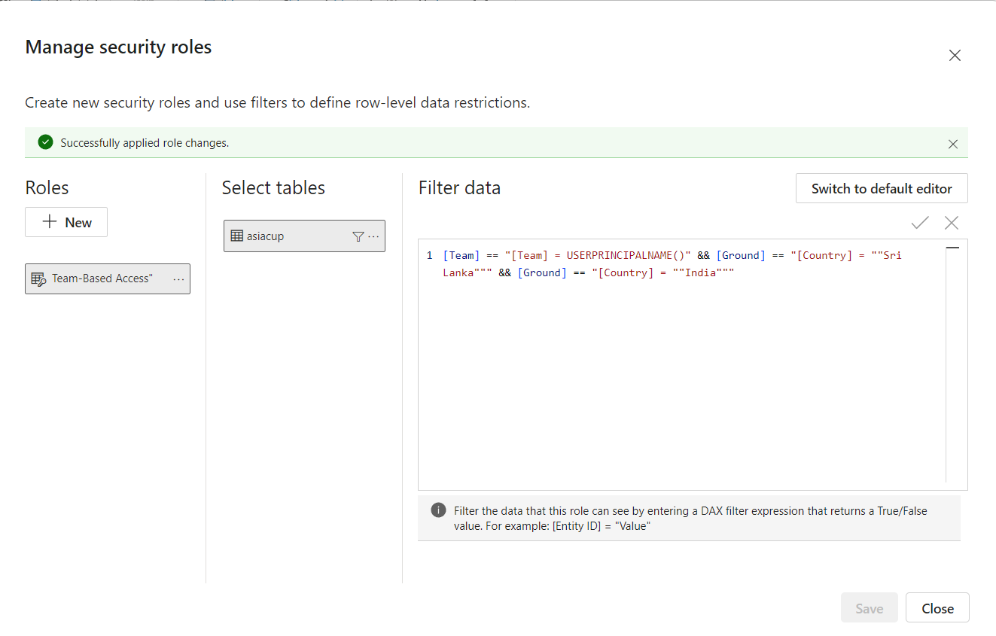

# Publish to PBI service.

Power BI's capacity to exchange insights across several formats for efficient company reporting is one of its main advantages. Key approaches include.

* **Exporting to PowerPoint**: Users may save visualizations and facilitate the sharing of insights in business meetings by exporting Power BI reports into PowerPoint presentations.
* **Including Power BI Reports in PowerPoint**: Power BI now enables interactive report embedding into PowerPoint presentations for real-time data analysis, replacing static exports.
* **Producing PDF Reports**: For formal documentation and broader distribution, reports may also be exported in PDF format.

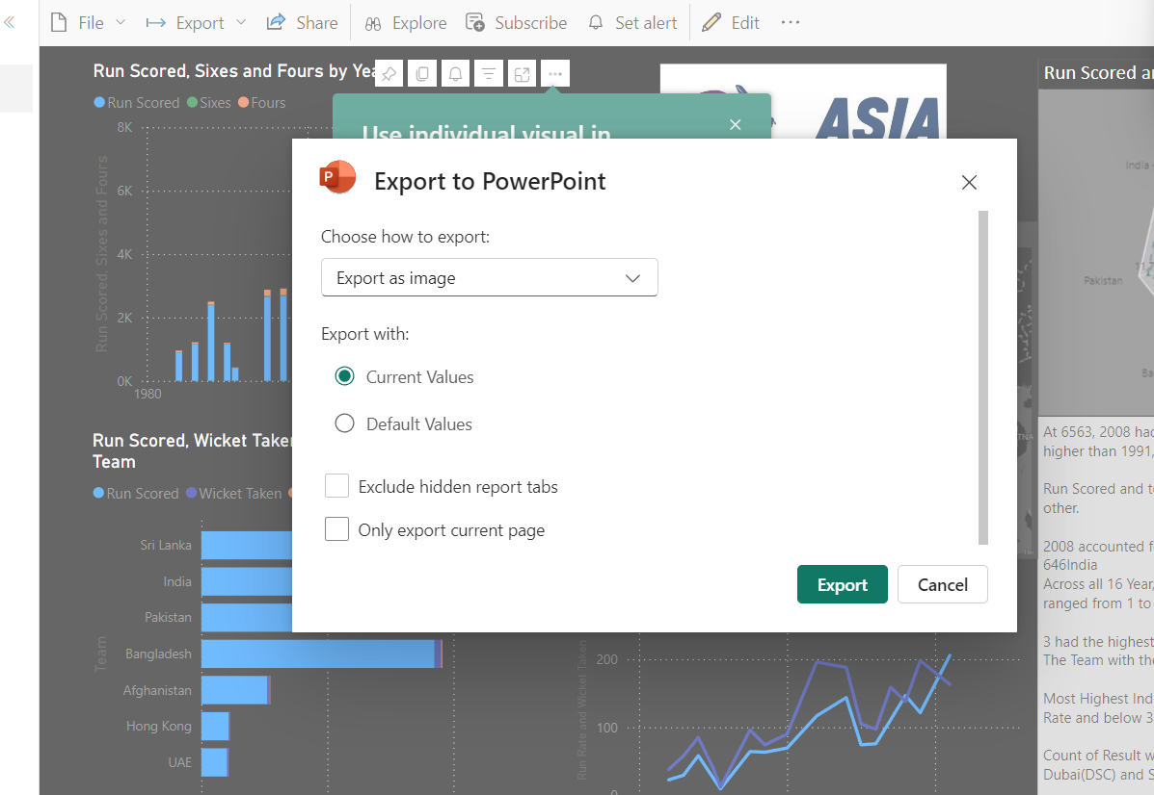

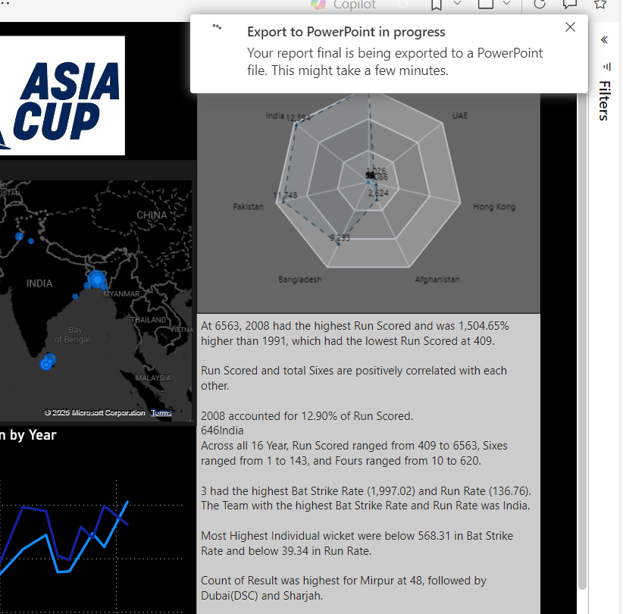

# References

espncricinfo, 2025. *espncricinfo.* [Online]   
Available at: https://www.espncricinfo.com/cricket-grounds/country/india-6  
[Accessed 05 02 2025].

espncricinfo, 2025. *espncricinfo.* [Online]   
Available at: https://www.espncricinfo.com/cricket-grounds/country/sri-lanka-8  
[Accessed 06 02 2025].

espncricinfo, 2025. *espncricinfo.* [Online]   
Available at: https://www.espncricinfo.com/cricket-grounds/country/united-arab-emirates-27  
[Accessed 05 02 2025].

selectiveasia, 2025. *selectiveasia.* [Online]   
Available at: https://www.selectiveasia.com/india-holidays/weather/september  
[Accessed 23 2 2025].

selectiveasia, 2025. *selectiveasia.* [Online]   
Available at: https://www.selectiveasia.com/sri-lanka-holidays/weather/september#:~:text=September's%20weather%20in%20detail&text=Sri%20Lanka's%20interior%20remains,freely%20in%20search%20of%20water.  
[Accessed 23 02 2025].

weather-and-climate, 2025. *weather-and-climate.* [Online]   
Available at: https://weather-and-climate.com/averages-Pakistan-September#weather-map  
[Accessed 23 02 2025].

weather-and-climate, 2025. *weather-and-climate.* [Online]   
Available at: https://weather-and-climate.com/averages-Bangladesh-September  
[Accessed 23 2 2025].

wikipedia, 2025. *wikipedia.* [Online]   
Available at: https://en.wikipedia.org/wiki/Asian_Cricket_Council  
[Accessed 05 02 2025].

wikipedia, 2025. *wikipedia.* [Online]   
Available at: https://en.wikipedia.org/wiki/Asia_Cup  
[Accessed 06 02 2025].